**Consumer Behavior Final Project: The Type of Consumer TikTok Attracts**

Elizabeth A. Morton, Ella Mahan, Elli McGowan, Noa Ben, Riley Rabuchin

BUS 396-01, March 7th 2024

Our team evaluated and analyzed the emerging presence of TikTok and focused our efforts on the type of consumer that TikTok influences in buying decisions to help answer the question: What type of consumer does TikTok attract?First, we examined the relationship between the age of a consumer and the number of hours that they spend on TikTok per day (see figure 1). This data shows a positive correlation between the two variables, indicating that as a person gets older, the time that they spend on TikTok decreases. Therefore, TikTok is more popular among a younger audience. These findings prompted us to further examine how correlated gender is with how many hours per day someone spends on TikTok.

We discovered that the average amount of time (hrs) that men spend on TikTok is 2.1759 and the average amount of time that women spend on TikTok is 2.2472 (see figure 2). These results indicated that both men and women spend about the same amount of time per day on TikTok on average, which is around 2 hours. The spread of data is very similar between the genders, but if anything, women have a slightly larger spread. This data, along with data from figure 1, explain the type of people who have an active presence on TikTok, which is younger men and women, and how long they spend scrolling, which is about 2 hours per day.

Next, we examined peoples’ sentiment towards TikTok compared to Instagram from articles published in the New York Times to examine the difference in people’s attitudes towards the two social platforms. For TikTok, the mean sentiment score is approximately 0.07434 and the mean sentiment score for Instagram is approximately 0.09691 (see figure 3). This data displays that TikTok has a lower sentiment score than Instagram, meaning that consumers feel more negatively towards TikTok than Instagram. This shows us that some TikTok consumers may prefer to use other platforms.

We then explored the sentiment toward TikTok over the past four years based on articles from the New York Times. Beginning from 2020 to 2024, the positive sentiment toward TikTok has increased (see figure 4). The positive correlation between the two displays the growing popularity of TikTok among people. We could argue that this correlation is due to the addition of Tik Tok Shop, which became a new feature of the platform within the time frame of this increased positive sentiment.

Next, to further investigate our research question regarding the type of consumer that TikTok attracts and see which consumers are turning to TikTok to purchase items, we measured the sentiment towards TikTok Shop Vs. In-Store Shopping (see figure 5). For in-store shopping, the mean sentiment score is approximately 0.07352. For TikTok Shop, the mean sentiment score is approximately 0.08087. The mean scores are relatively close to each other, suggesting that consumers feel similar towards TikTok Shop and in-store shopping.

We then used consumers’ impulsivity to predict annual income in order to discover if people impulsively buying off of TikTok Shop tend to have higher incomes. We did this by having participants self-report their annual income, and then we measured their impulsive buying habits on a scale from 1-5 (see figure 6)**,** with 1 being minimal impulsivity and 5 being very impulsive. By observing the data, we found a positive correlation between participants' impulsivity and their annual income. In other words, the more impulsive a consumer is, the larger their annual income tends to be.

In order to determine the correlation between impulsivity and the number of products that a consumer purchases per month, consumers were asked “How many products have you purchased off of social media?” Their impulsivity was also measured on a scale from 1-5, with 1 being minimal impulsivity and 5 being very impulsive (see figure 7). Our findings displayed that as a person’s impulsivity goes up, the number of products that they purchase off of social media per month goes up. This indicates that more impulsive people tend to buy more products off of social media platforms. Additionally, along with the data collected from figure 2, we predict that young men and women who are impulsive buyers are typically the consumers attracted to the products sold on TikTok.

In order to further examine our research question and discover the correlation between impulsivity and materialism, we surveyed participants using questions such as, “How long do you think about purchasing a product before buying it?” and “Select the answer that applies to you.” Where participants were asked to rank various categories such as “I admire people who own expensive homes, cars, and clothes,” and “I like to own things that impress people” on a scale of “strongly disagree” to “strongly agree.” Then when we found the correlation between our results for these we got a positive correlation between materialism and impulsivity among the survey respondents. This is indicated by the correlation coefficient (see figure 8). This suggests that the more materialistic a person is the more impulsive they are.

Additionally, we wanted to look at what motivates consumers to purchase products from TikTok (see figure 9). We discovered that 69.49% said “a large markdown,” 13.56% said the product “popped up on their feed,” 11.86% said “customer reviews,” and 5.08% said “ads.” This data displays that consumers who are shopping on TikTok are primarily hoping to get large markdowns.

To expand on the data from figure 9, we were hoping to determine consumer values when buying products online. To do this, we surveyed participants about the most important factor to them when buying online. 74.23% said “quality,” 23.71% said “fair price,” 2.06% said if “other people have it,” and 0.00% said “fast shipping” (see figure 10). This shows us that when a customer is buying online, the quality of the product is the most important factor in their decision.

After taking all of the data that we collected and analyzed into consideration, we can confidently say that all of the findings provide relevant information in regards to our research question. Our data revealed that TikTok consumers tend to be both younger and evenly spread between males and females. The data also showed that ironically, consumers purchase on TikTok for the benefit of “a large markdown” while also expecting “quality” products. However, this does align with TikTok Shop’s actual role in the app, as it is known to offer consumers great deals without compromising the quality of the products.

**Appendix**

**Figure 1**

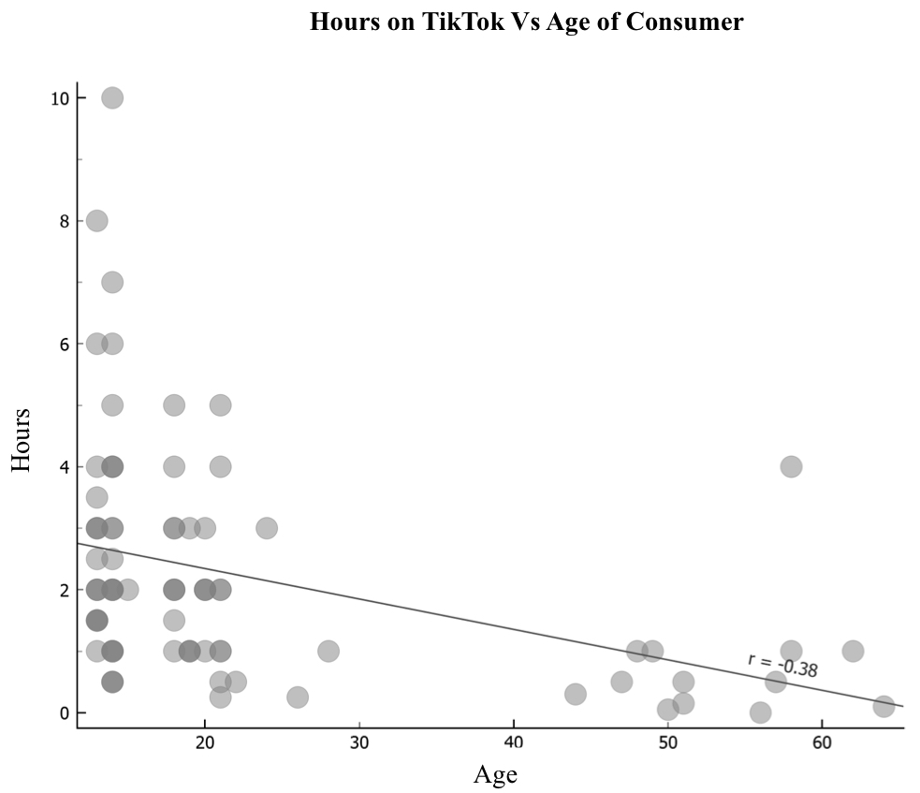

“Qualtrics Survey Data.” BUS 396-01, Winter 2024

**Figure 2**

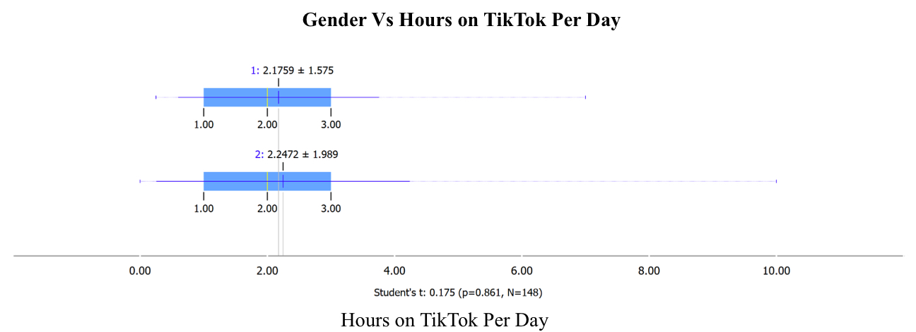

“Qualtrics Survey Data.” BUS 396-01, Winter 2024

**Figure 3**

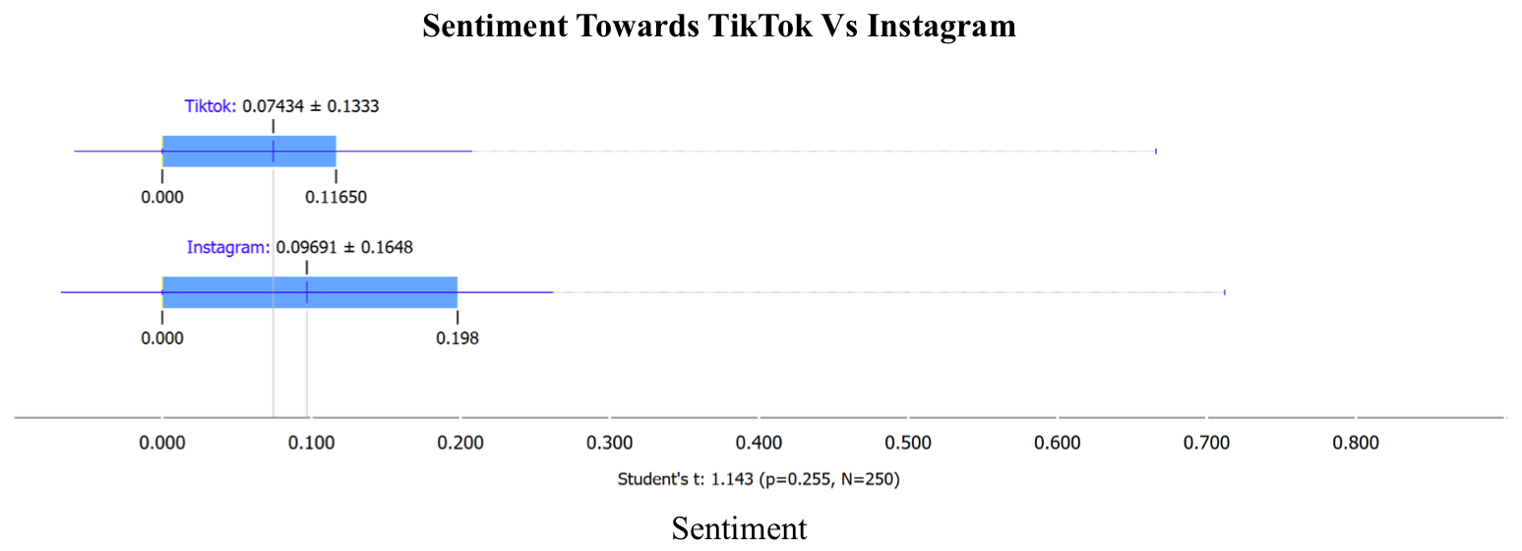

New York Times, October 2023 - March 2024

**Figure 4**

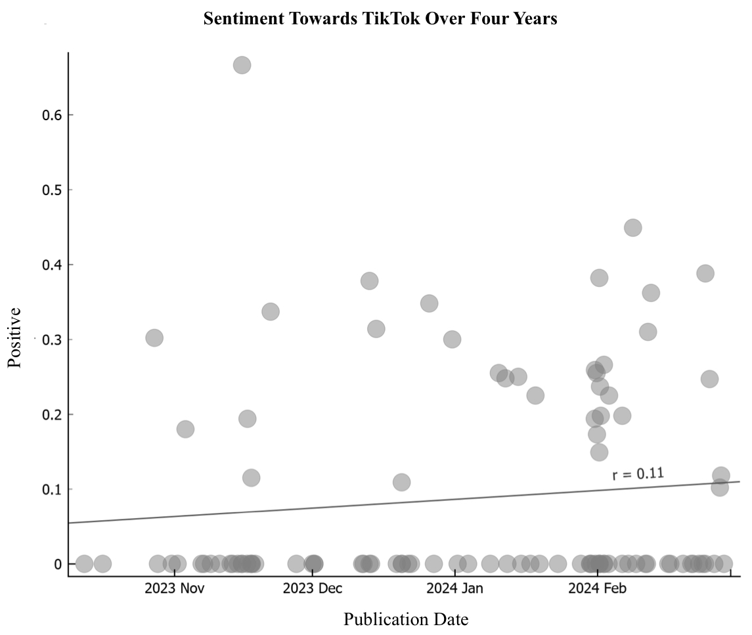

New York Times, October 2023 - March 2024

**Figure 5**

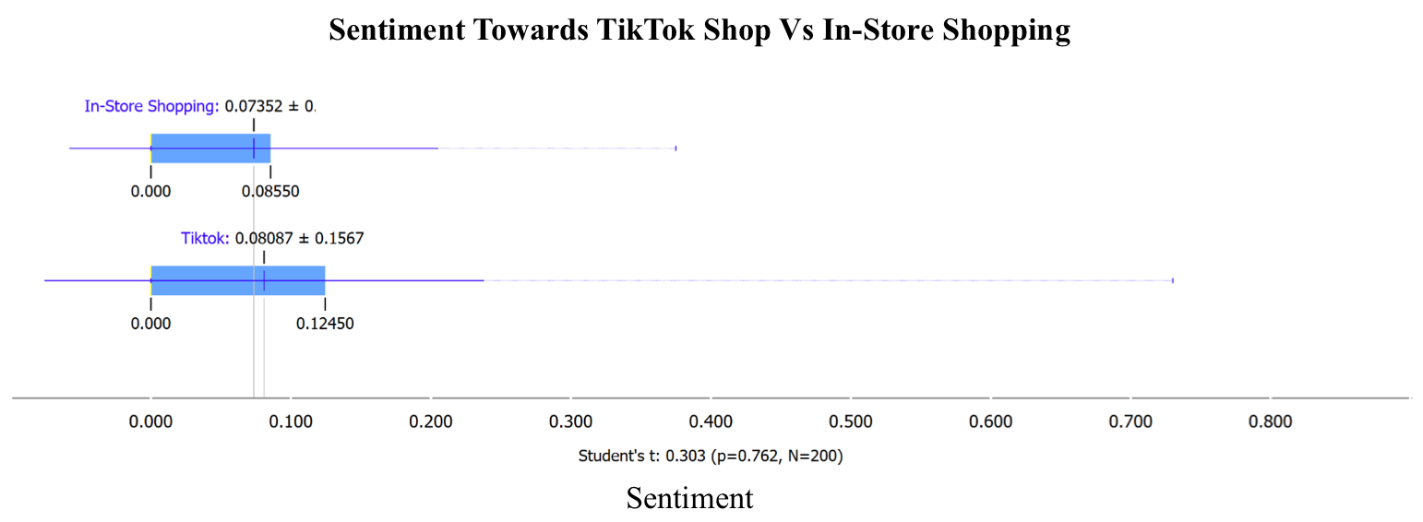

New York Times, October 2023 - March 2024

**Figure 6**

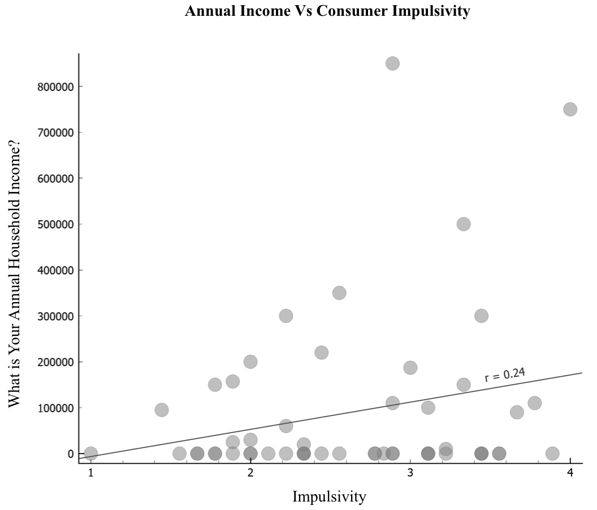

“Qualtrics Survey Data.” BUS 396-01, Winter 2024

**Figure 7**

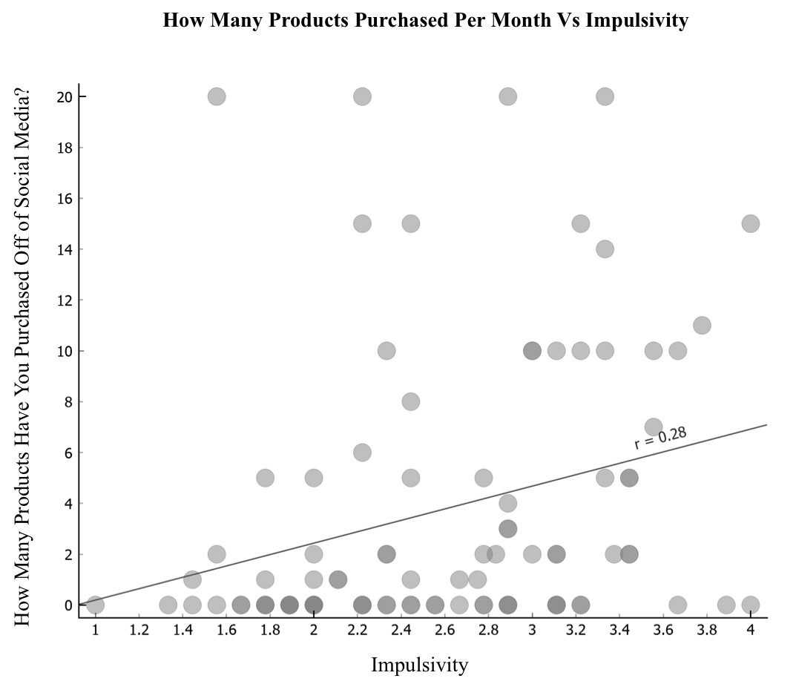

“Qualtrics Survey Data.” BUS 396-01, Winter 2024

**Figure 8**

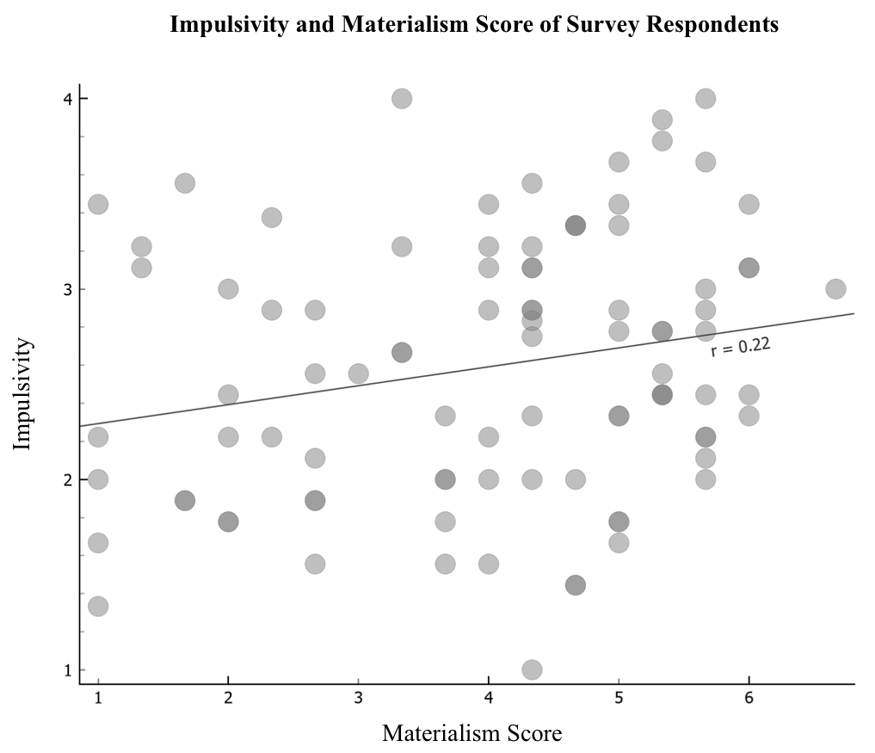

“Qualtrics Survey Data.” BUS 396-01, Winter 2024

**Figure 9**

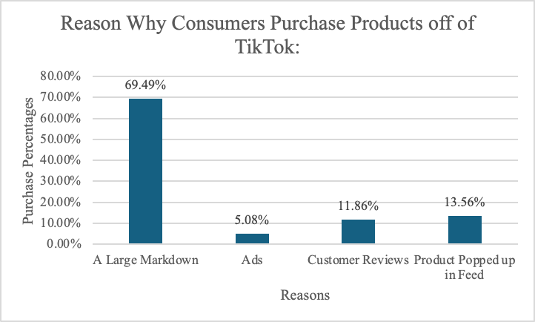

“Qualtrics Survey Data.” BUS 396-01, Winter 2024

**Figure 10**

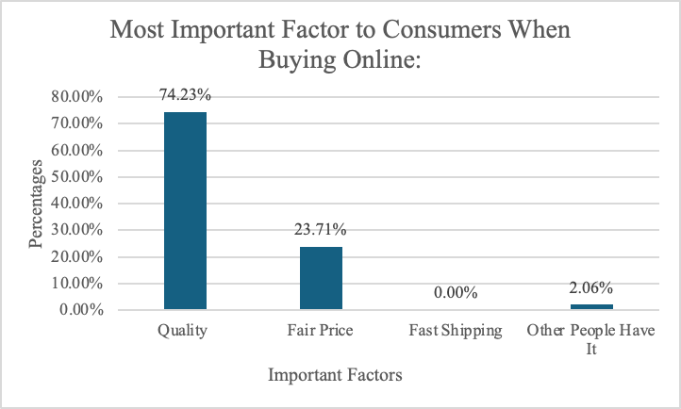

“Qualtrics Survey Data.” BUS 396-01, Winter 2024